<https://www.youtube.com/watch?v=h4kBcmIYIZ4&ab_channel=GreatLearning>

<https://www.youtube.com/watch?v=_fbN5msjZkU&ab_channel=EngineersGrowth>

<https://www.youtube.com/watch?v=P7hgmMlw6CY&t=2761s&ab_channel=BangOnTheory>

1)feature of java??

Simple

Object oriented

Robust

Platform independent

Secure

Multithreded

Distributed

High performance

2)kewwords in java?

It is reserved word which used in indentifire,function

There are 52 keyword in java8

Keywords are:-final, int,break,if,else etc

3)what are literal in java??

Literal refer to variable or constant

5 type of literal are:-

String)

Integer

Boolean

Char

Floating point

6) difference b/w JDK/JVM/JRE?

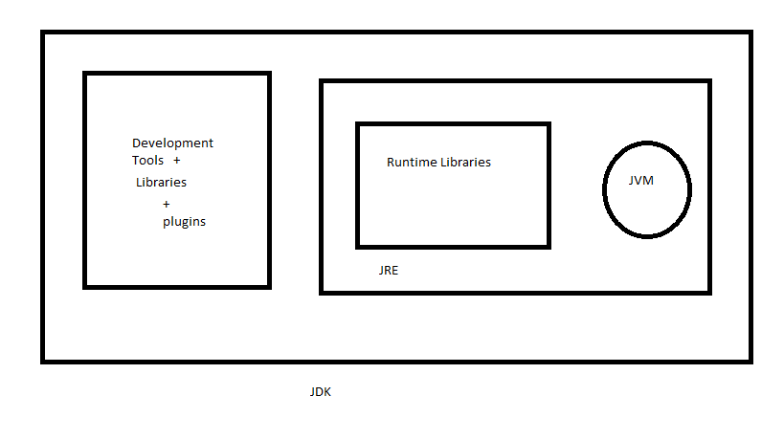

JDK:

1)it is java development kit

2)it role is compile,document, package

3)It contain jre+ development tools

JRE:

1)It is java runtime engine

2)It is runtime engine java bytecode is executed

3)It is physically exist

4)It is the implementation of jvm

JVM:

1)It is java virtual machine

2) is runtime engine java bytecode is executed

3)It is abstract/virual

4)it follow 3 notation specification, implementation and runtime instance

7)what is platform independent?

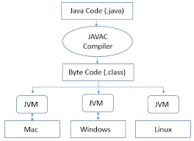

Bycode is running on any system

8)public static void main(String[] args) mean?

Main()->it is the entry point in java

Public()-> it is an access modifier.it can be access by any class

Void()=>it is the return type .which will not return any value

Static->It is accessed by without creating an object.before any object create only static is directly invoked

String args[]->

8)Why java is not purely object oriented?

Reason Object orientedprograming is everthing is object. But in java primitive data type is not object

9)What is wrapper class in java?

Wrapper class convert java primitive into reference type

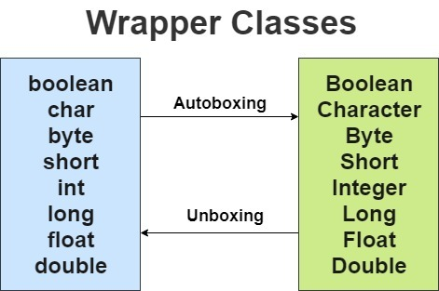

10)Constructor in java?

1)It is initialize an object

2)It’s name same as class name

3)it is no return type

4)it is automatically called

2 types:-

1)Default Constructor->

1)it has no argument

2)it is called default if no any constructor is define. So it initialized the default value of variable

3)It is mainly responsible for object creation

2)Parameterized constructor

1)it has multipleargument

2)it is initialized by paramerterised value

11)what is singleton in java? How make a class singleton?

1)it is class whose only one instance is created at a give time

Class make a singleton by making is constructor private.

12)Differnce b/w array list and vector??

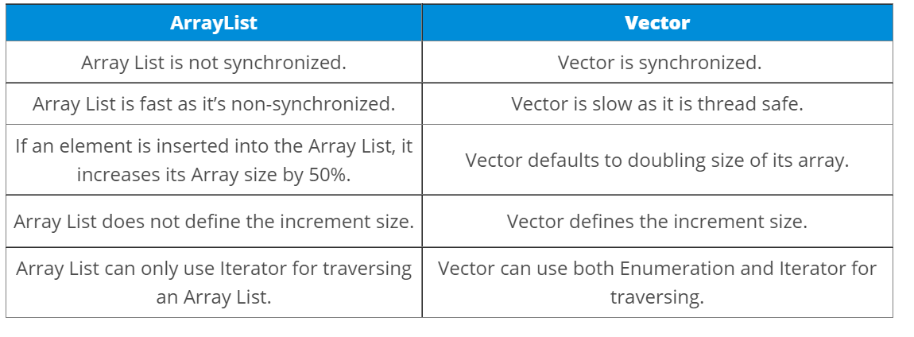

13)what is the difference b/w equals() and ==?

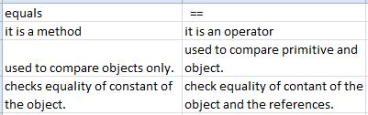

14)Differnce b/w heap and stack??

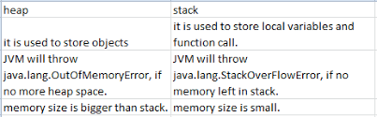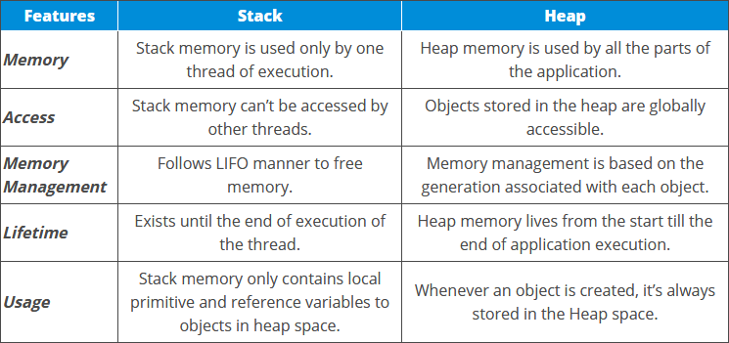

15 Why pointer are not used in java??

16) what is jit compiler in java??

17) what are the access modier??

18)what is java class??

19) what is object in java??

20)what is oops?

21) difference b/w local variable and instance variable??

22)difference b/w constructor and methods??

23)what is final keyword in java??

24)difference b/w break and continue??

25)what is the infinite loop in java??

26)Differnce b/w this and super?

27)what is java string pool??

28)what is static and non static method?

29)what is constructor chaining in java??

30)difference b/w String , String Buffer, String Builder??

31)what is class loader in java??

32)why java string are immutable in nature??

33)difference b/w array and arraylist??

34)what is map in java??

35) what is collection in java? List down its methods and interface??

36)what is polymorphism??

37) How many ways achieve abstraction?

1)abstract

2)interface

37) what is abstraction in java??

Hiding internal details and ony show functionality

Its implementation is provided in child class.

38) what do you mean by interface in java??

100% abstraction achieved in interface

39)difference b/w abstract and interface??

40) what is inheritance in java ??

41)what are the different types of inheritance in java??

42)what is method overloading and method overriding??

43)what is multiple inheritance? Is it supported by java??

44)what is encapsulation in java??

For data hiding by using private

Encapsulation achieve by 2 ways:-

1)Private data we can’t be access dirtectly. we can access through getter/setter method

2)encapsulation using constructor with getter/setter

45)what is an association??

46)what is composition in java??

47)what is object cloning in java??

48)what is copy constructor in java??

49)how many type of memory area in jvm??

50)what is default value of local variable??

51)what if Iwrite static public void instead of public static void??

52)what is the purpose of static methods and variable?

53)advantage of packages in java??

54)difference b/w object oriented programming and object based programming language??

55)Does constructor return any value??

56)can u make a constructor final??

57)what will be the initial value of an object reference which is defined as an instance variable?

58) is constructor is inherited?

59)difference b/w constructor and methods

60)can override the static methods?

61)what are the restriction applied to the java static methods?

62)what is static block?

63)can we execute program without main method?

64)what if the static modifier is removed from the signature of main method?

65)diffence b/w static method and instance method?

66)can wemake a constructor static??

67)can we make the abstract method static in java??

68)can we declare static variable and method in abstract class??

69)uses of this keyword?

70)can we assign the reference of this variable?

71)can this keyword be used to refer static member?

72)what are the advantage of passing this into a method instead of current class object itself?

73)why multiple inheritance not support in java?

74)what is aggregation?

75)difference b/w this and super??

76)can u use this and super both in a constructor??

77)why is method overloading is not possible changing the return type in java??

78)can we overload the methods by making them static??

79)can we overload main method??

80)Rules of method overloading??

81)can override the static methods??

82)can we override the private methods??

83)why can we not override static method??

84)what is covariant return type?

85)what is final vaiable?

86)what is final method?

87)what is final class??

88)can we declare constructor is final?

89)difference b/w final method and abstract method?

90)can we declare interface as final?

91)access modifier?

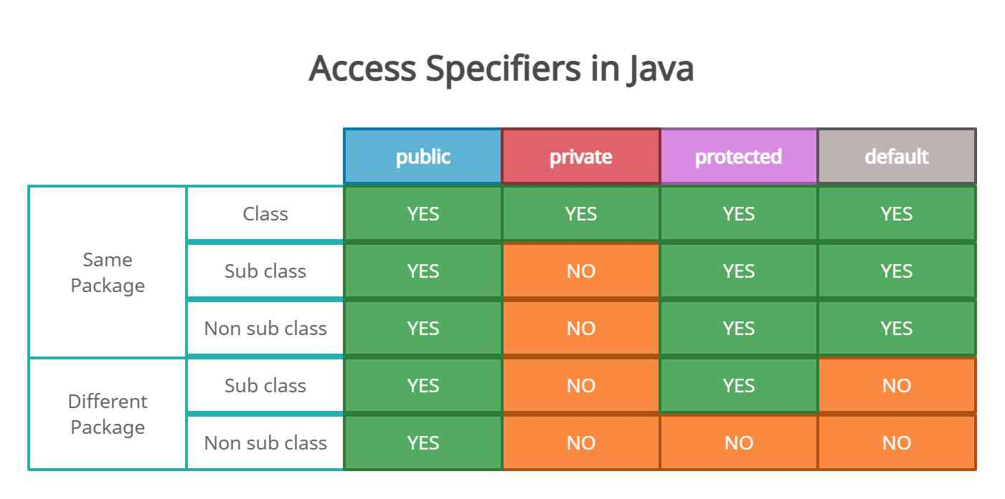

91) what is oops concept??